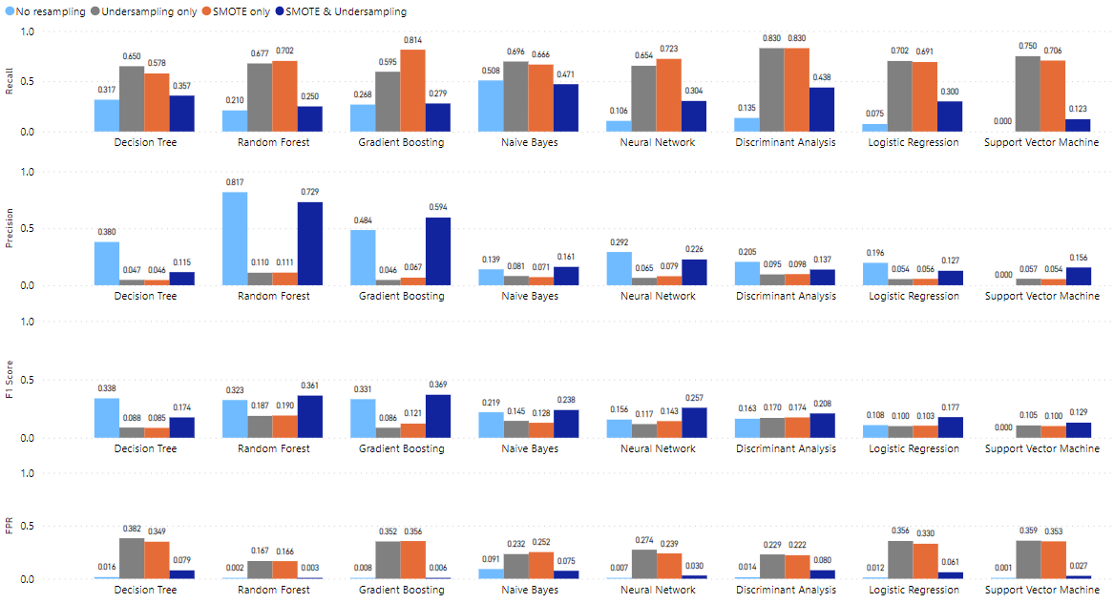

**Figure 5.** Model performance comparison with and without resampling based on item responses, response time and summative statistics with a ratio of 1:1 between the non-cheater and cheater classes.

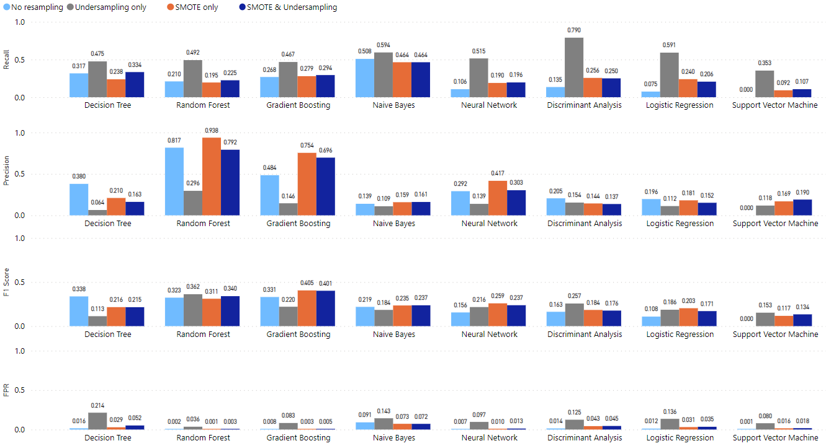

**Figure 6.** Model performance comparison with and without resampling based on item responses, response time and summative statistics with a ratio of 2:1 between the non-cheater and cheater classes.

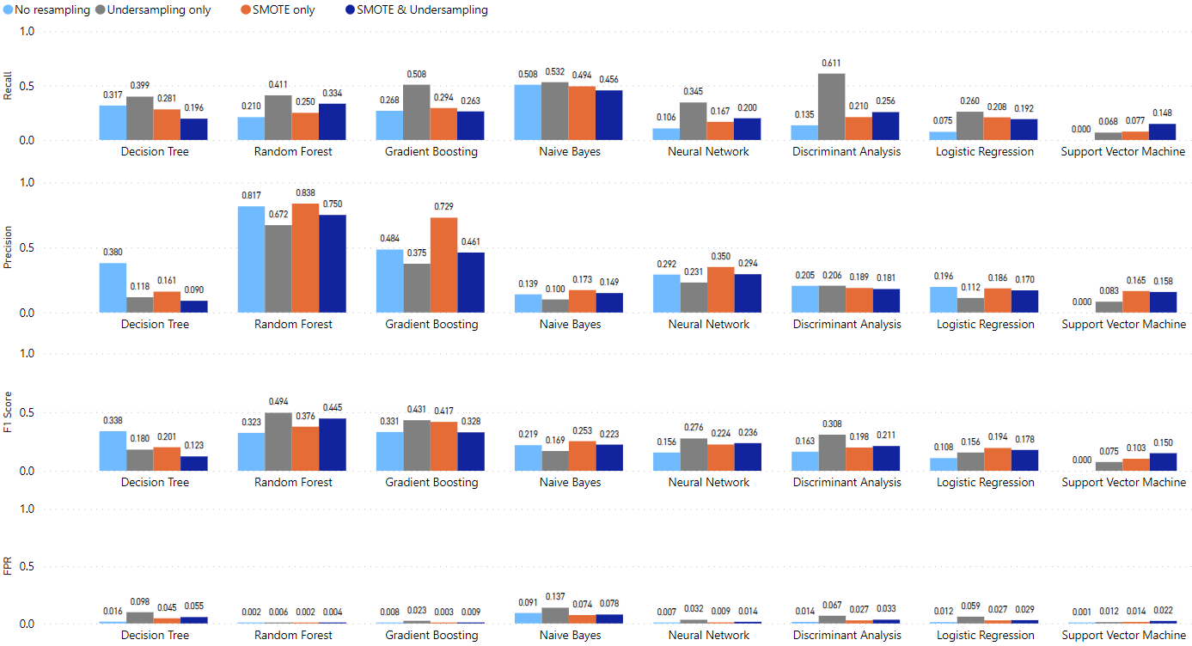

**Figure 7.** Model performance comparison with and without resampling based on item responses, response time and summative statistics with a ratio of 5:1 between the non-cheater and cheater classes.

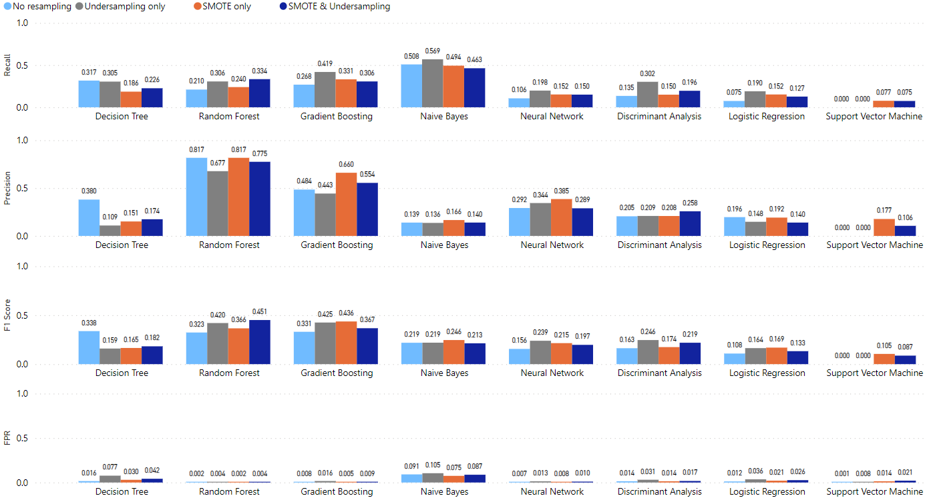

**Figure 8.** Model performance comparison with and without resampling based on item responses, response time and summative statistics with a ratio of 10:1 between the non-cheater and cheater classes.

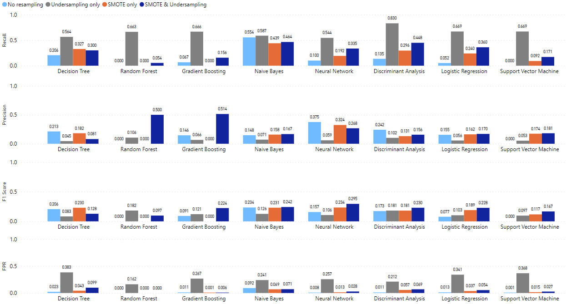

**Figure 1.** Performancecomparison of models with and without resampling based on item response, response time with a ratio of 1:1 between the non-cheater and cheater classes.

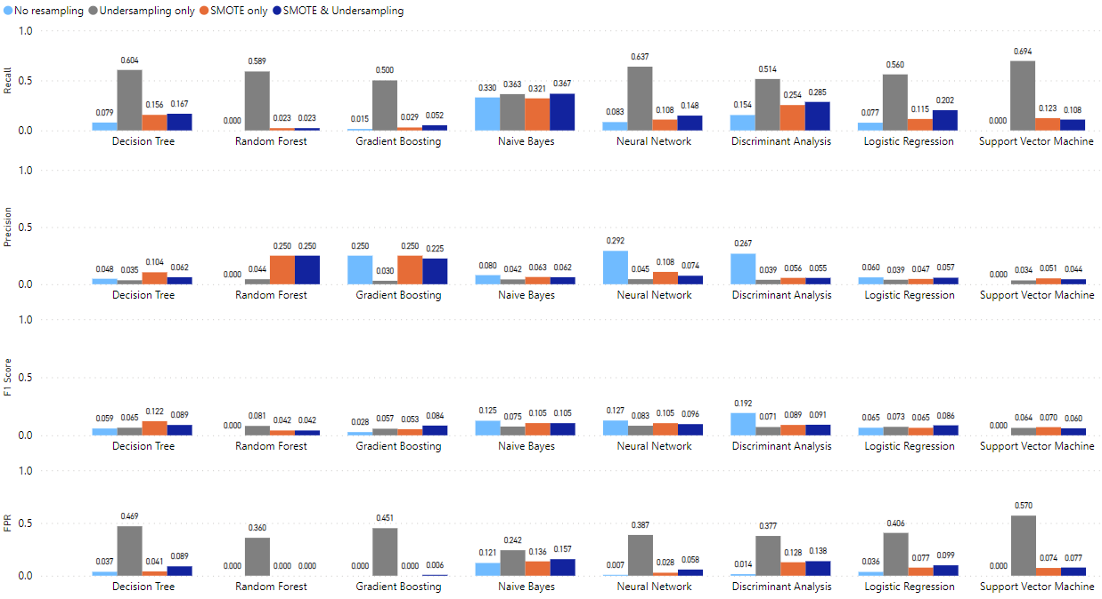

**Figure 2.** Performancecomparison of models with and without resampling based on item response with a ratio of 1:1 between the non-cheater and cheater classes.

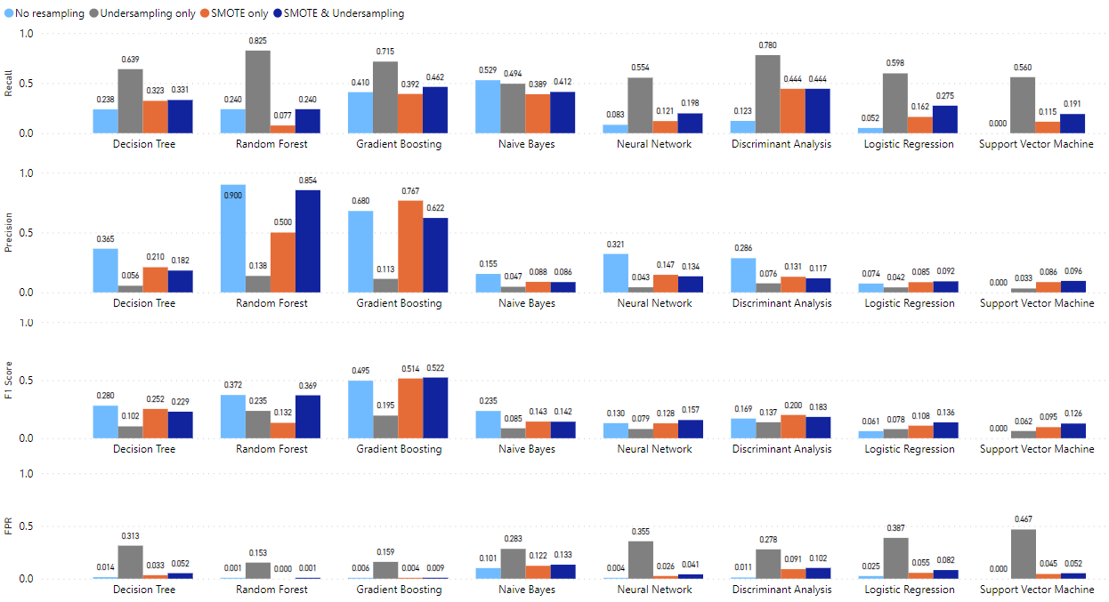

**Figure 3.** Performancecomparison of models with and without resampling based on item response and summative statistics with a ratio of 1:1 between the non-cheater and cheater classes.

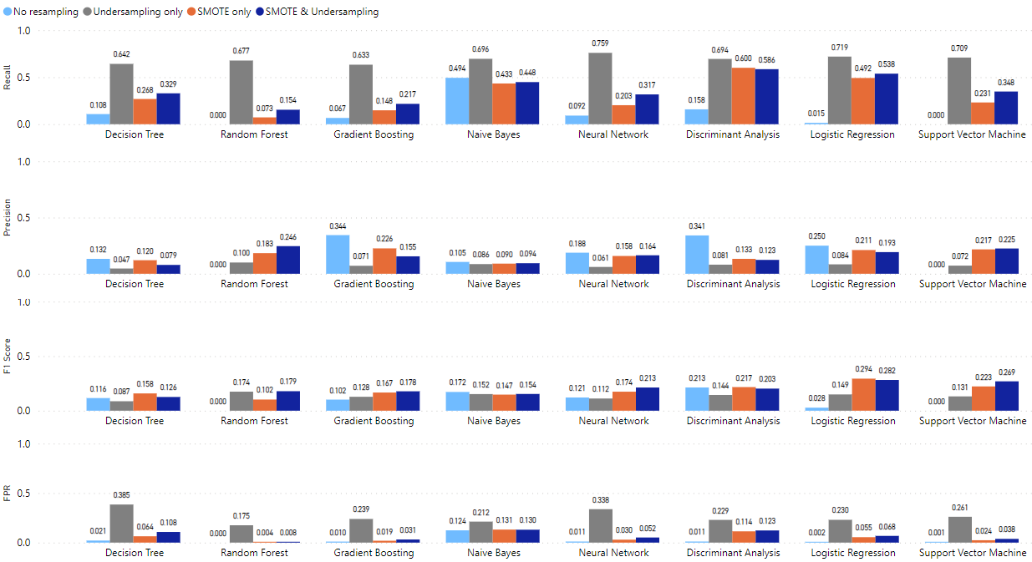

**Figure 4.** Performancecomparison of models with and without resampling based on response time with a ratio of 1:1 between the non-cheater and cheater classes.

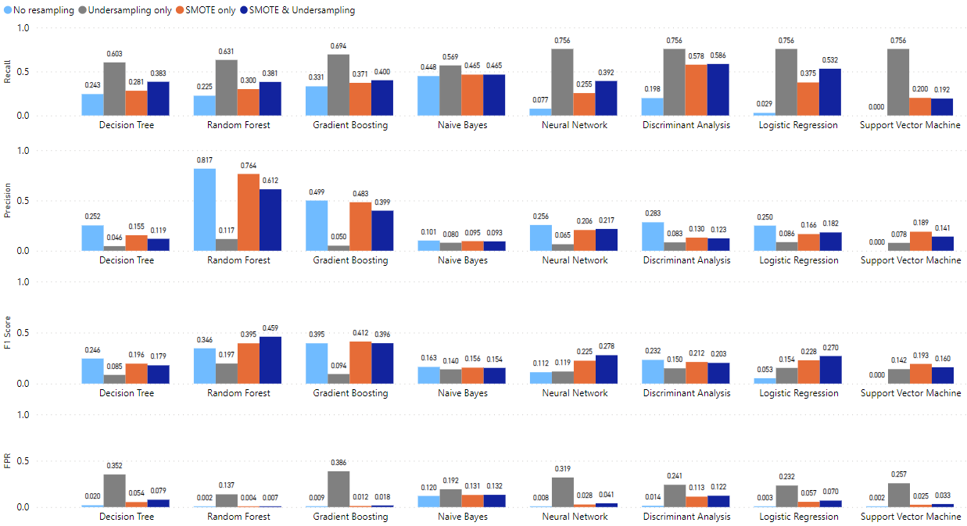

**Figure 5.** Performancecomparison of models with and without resampling based on response time and summative statistics with a ratio of 1:1 between the non-cheater and cheater classes.

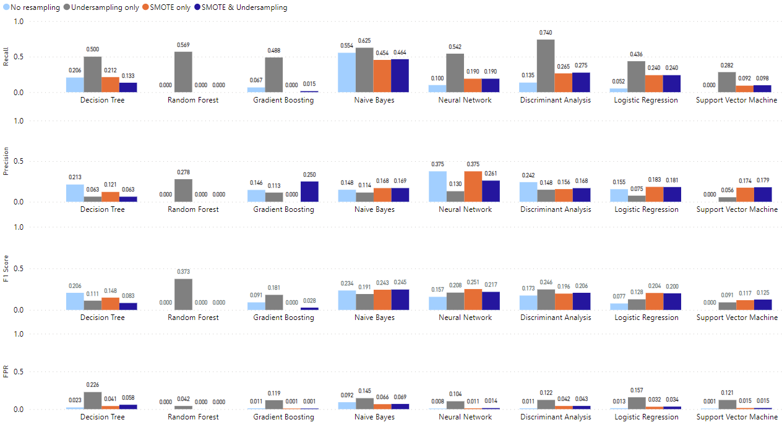

**Figure 6.** Performancecomparison of models with and without resampling based on item response, response time with a ratio of 2:1 between the non-cheater and cheater classes.

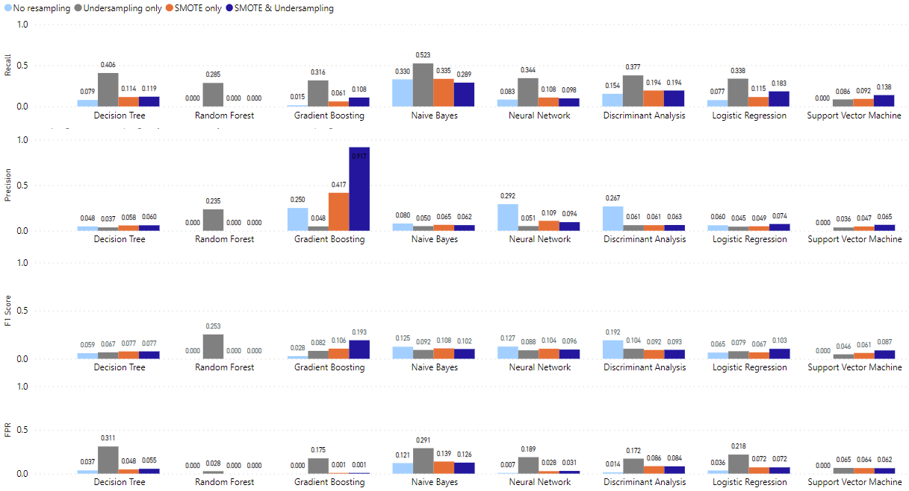

**Figure 7.** Performancecomparison of models with and without resampling based on item response with a ratio of 2:1 between the non-cheater and cheater classes.

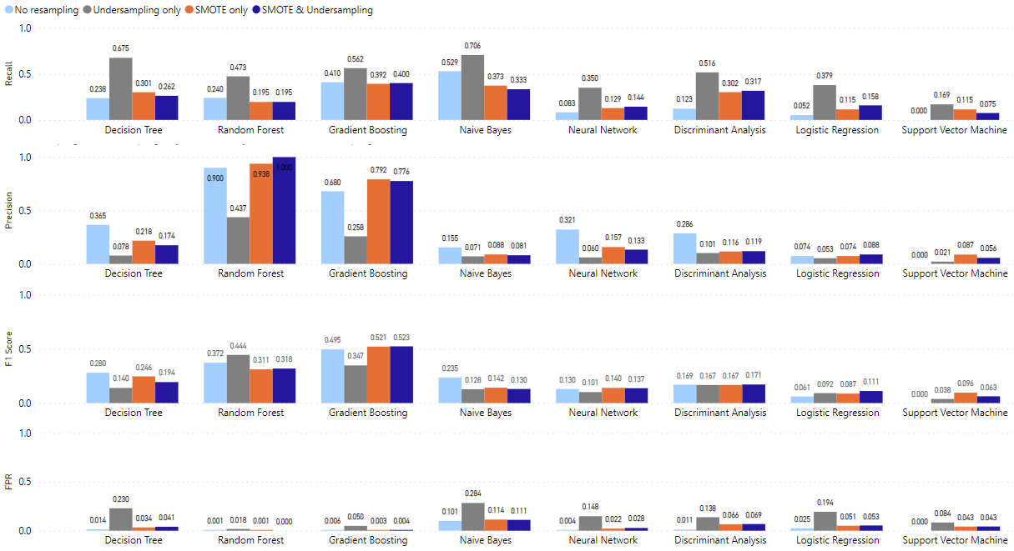

**Figure 8.** Performancecomparison of models with and without resampling based on item response and summative statistics with a ratio of 2:1 between the non-cheater and cheater classes.

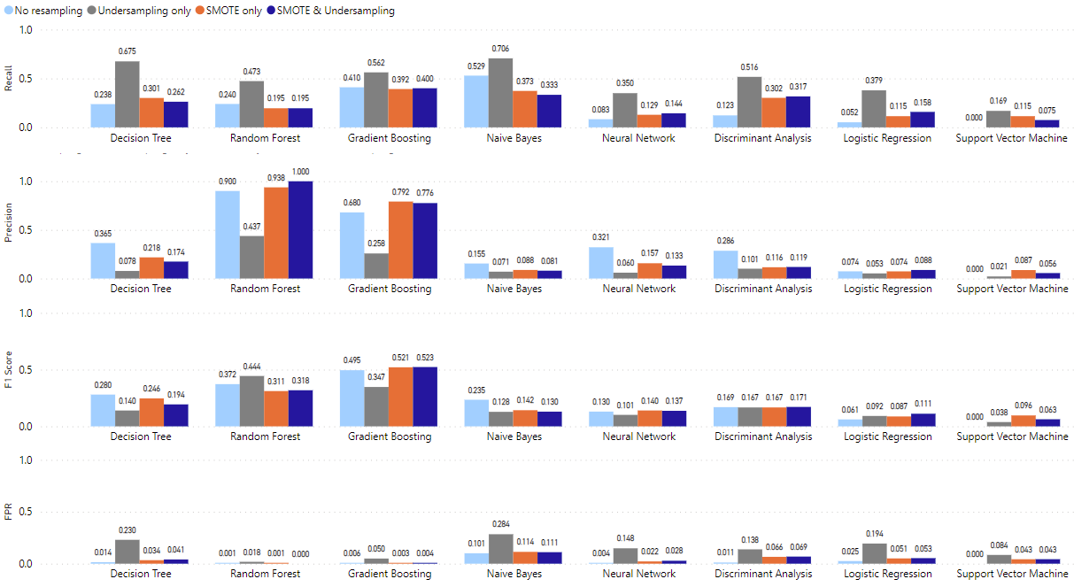

**Figure 9.** Performancecomparison of models with and without resampling based on response time with a ratio of 2:1 between the non-cheater and cheater classes.

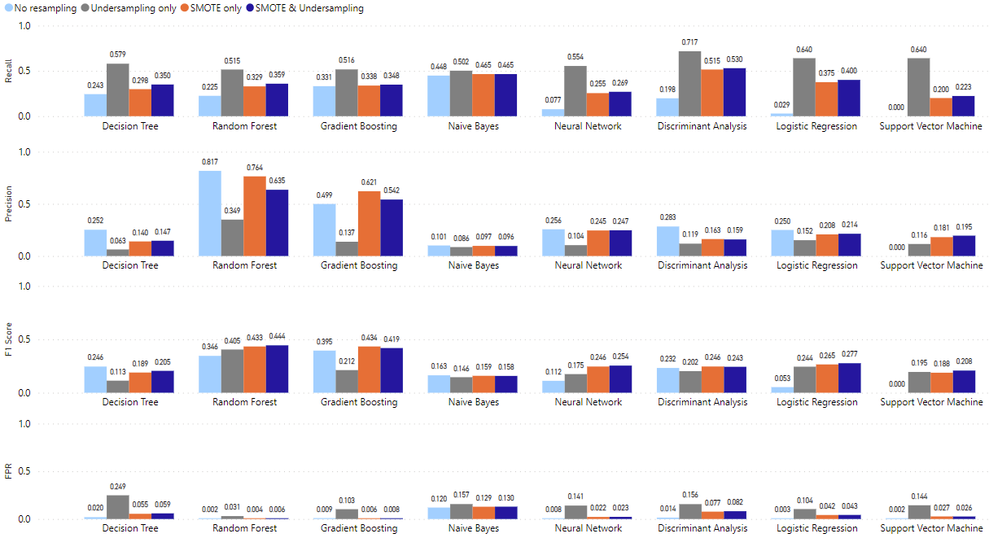

**Figure 10.** Performancecomparison of models with and without resampling based on response time and summative statistics with a ratio of 2:1 between the non-cheater and cheater classes.

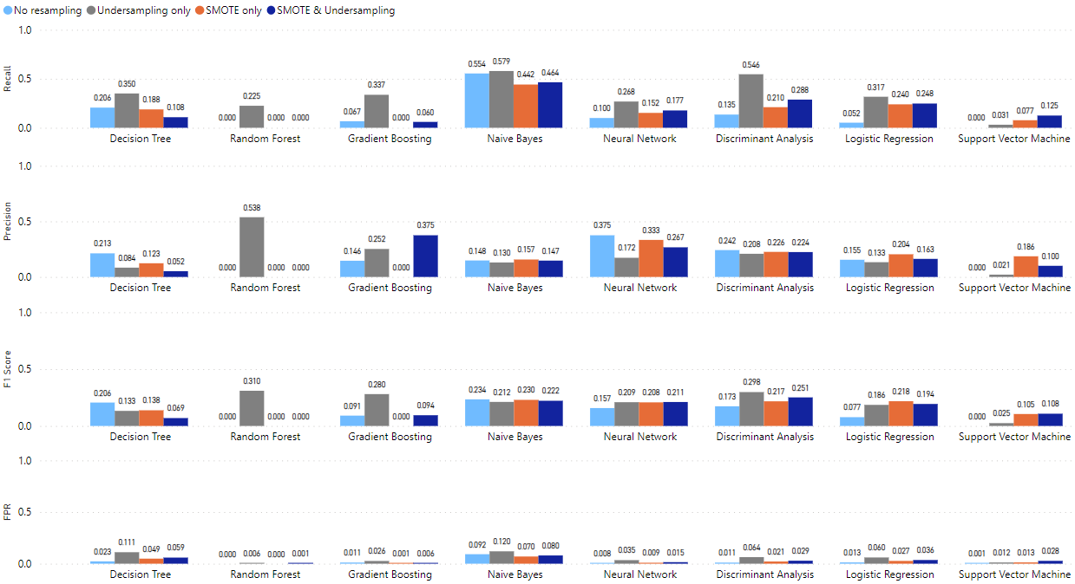

**Figure 11.** Performance comparison of models with and without resampling based on item response, response time with a ratio of 5:1 between the non-cheater and cheater classes.

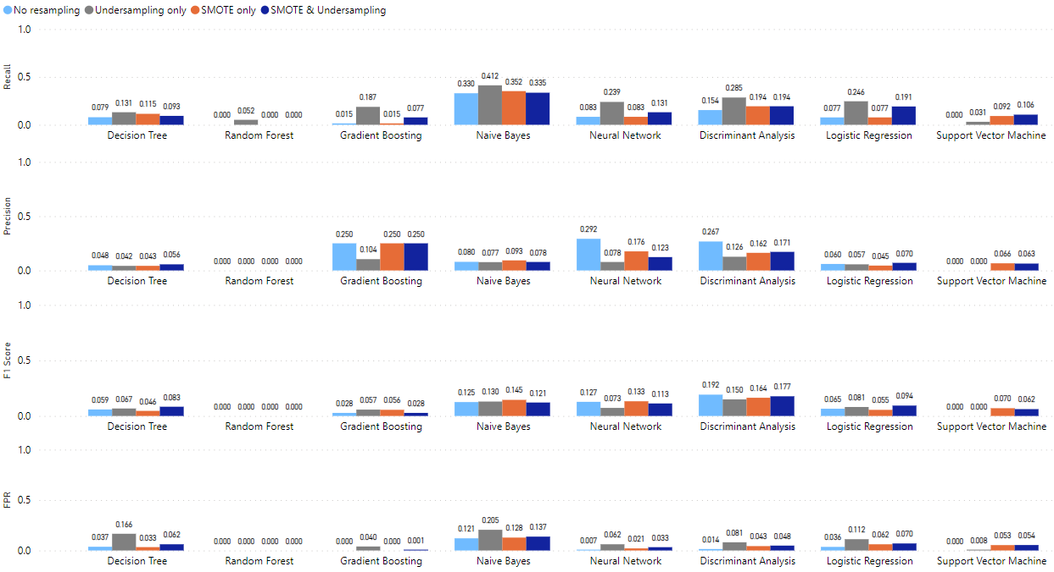

**Figure 12.** Performance comparison of models with and without resampling based on item response with a ratio of 5:1 between the non-cheater and cheater classes.

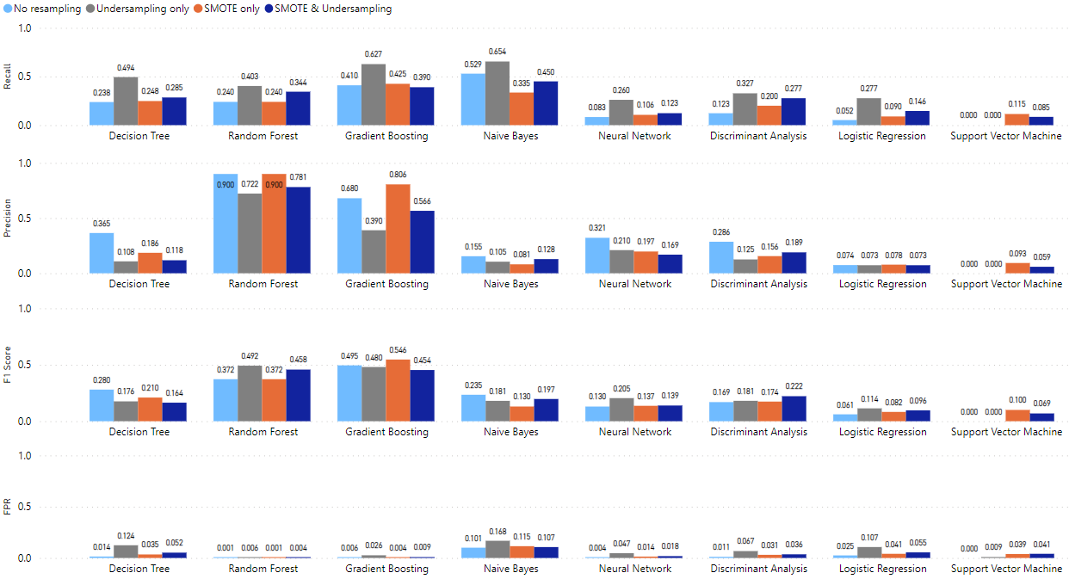

**Figure 13.** Performance comparison of models with and without resampling based on item response and summative statistics with a ratio of 5:1 between the non-cheater and cheater classes.

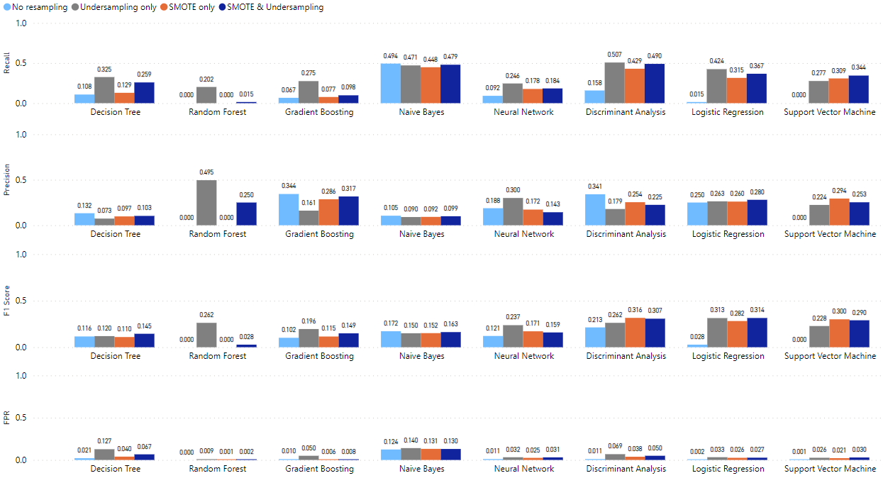

**Figure 14.** Performance comparison of models with and without resampling based on response time with a ratio of 5:1 between the non-cheater and cheater classes.

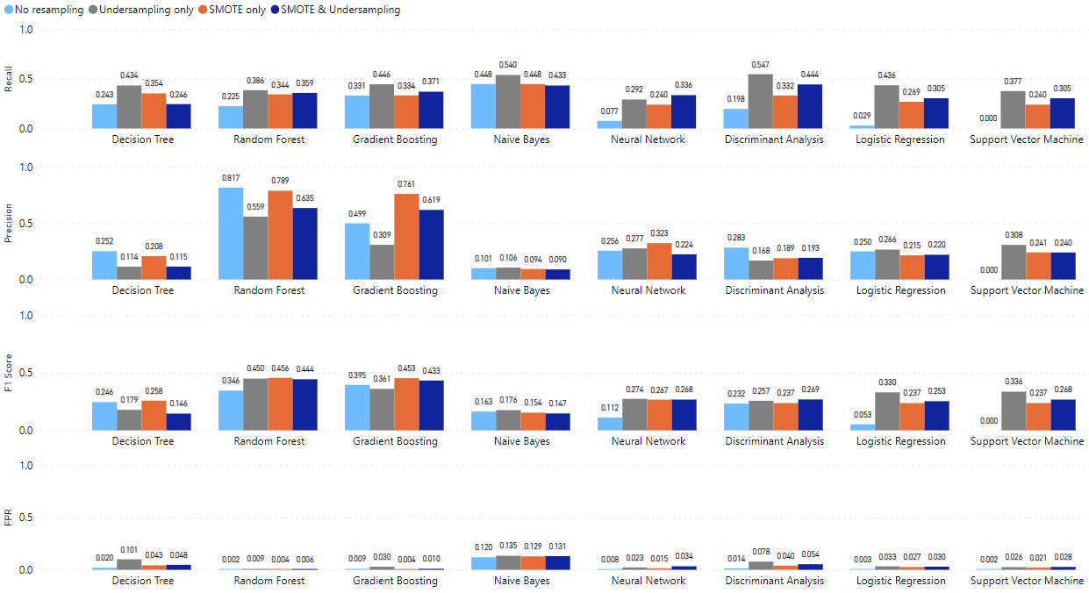

**Figure 15.** Performance comparison of models with and without resampling based on response time and summative statistics with a ratio of 5:1 between the non-cheater and cheater classes.

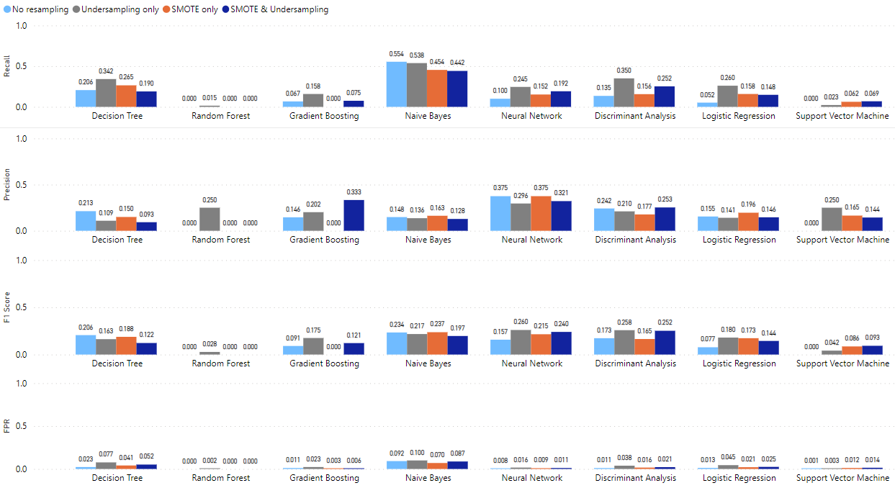

**Figure 16.** Performance comparison of models with and without resampling based on item response, response time with a ratio of 10:1 between the non-cheater and cheater classes.

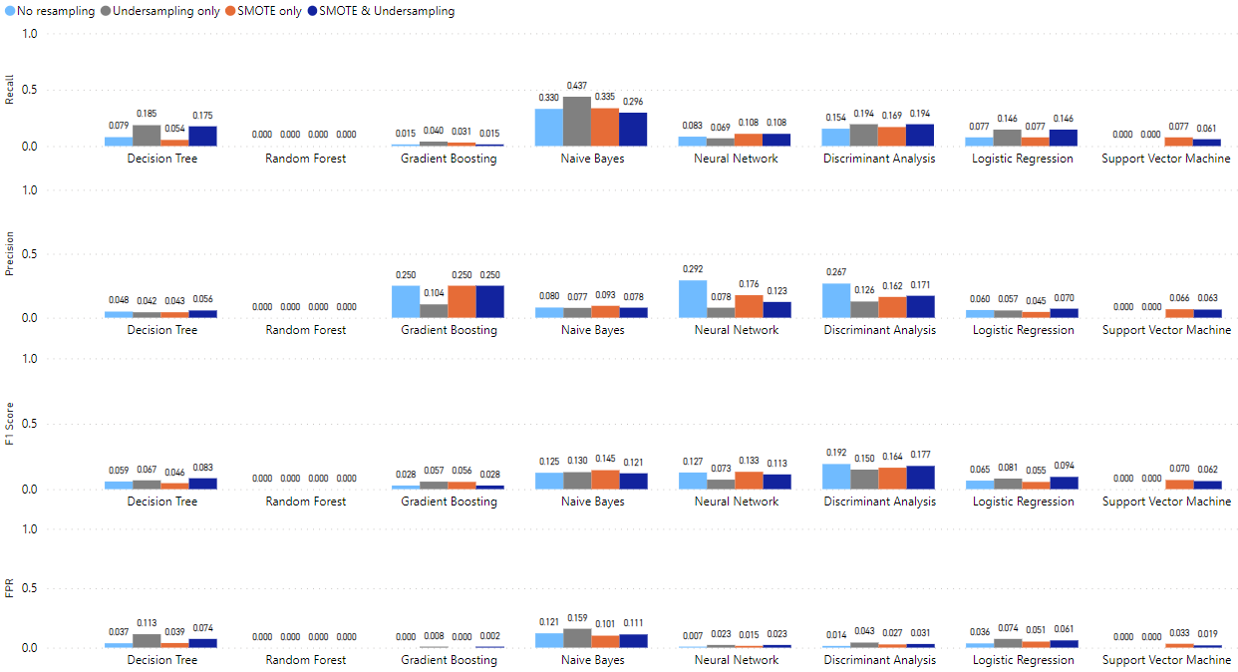

**Figure 17.** Performance comparison of models with and without resampling based on item response with a ratio of 10:1 between the non-cheater and cheater classes.

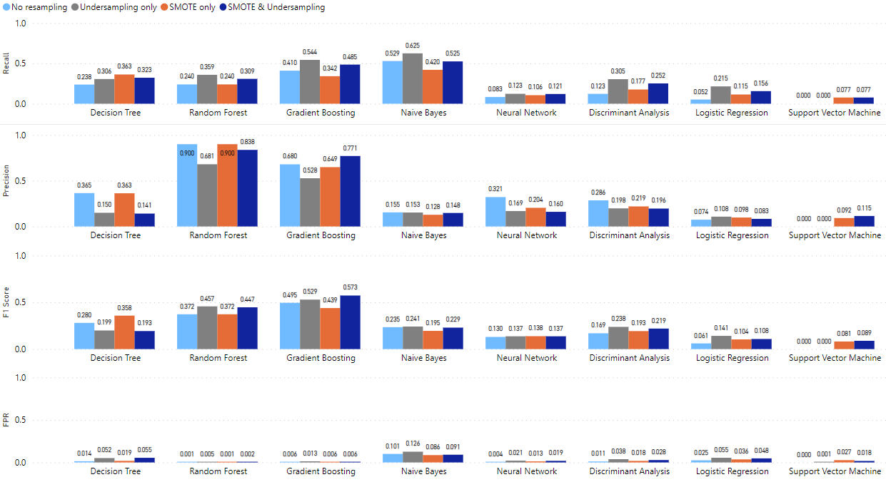

**Figure 18.** Performance comparison of models with and without resampling based on item response and summative statistics with a ratio of 10:1 between the non-cheater and cheater classes.

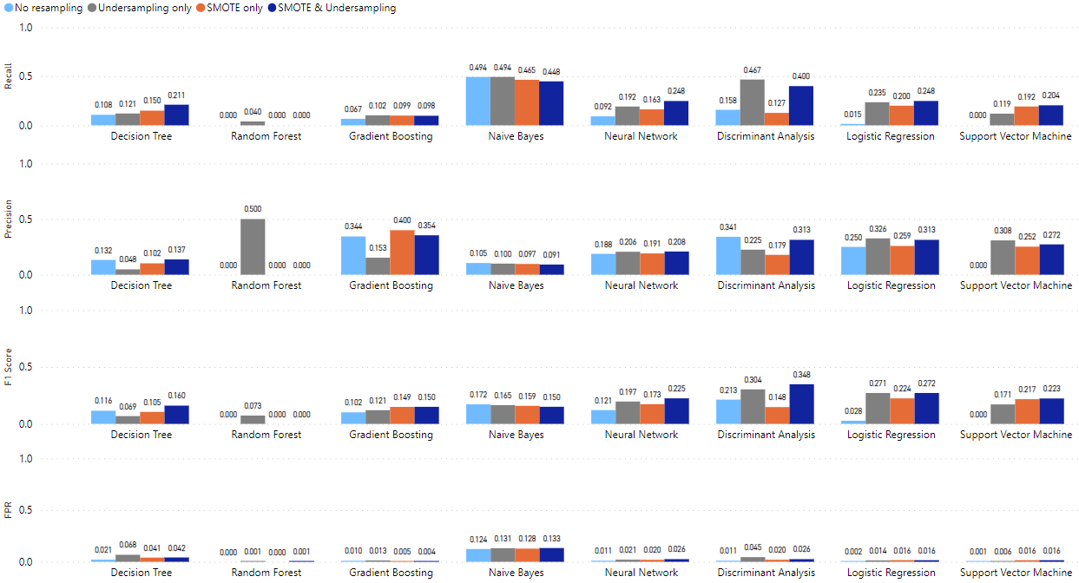

**Figure 19.** Performance comparison of models with and without resampling based on response time with a ratio of 10:1 between the non-cheater and cheater classes.

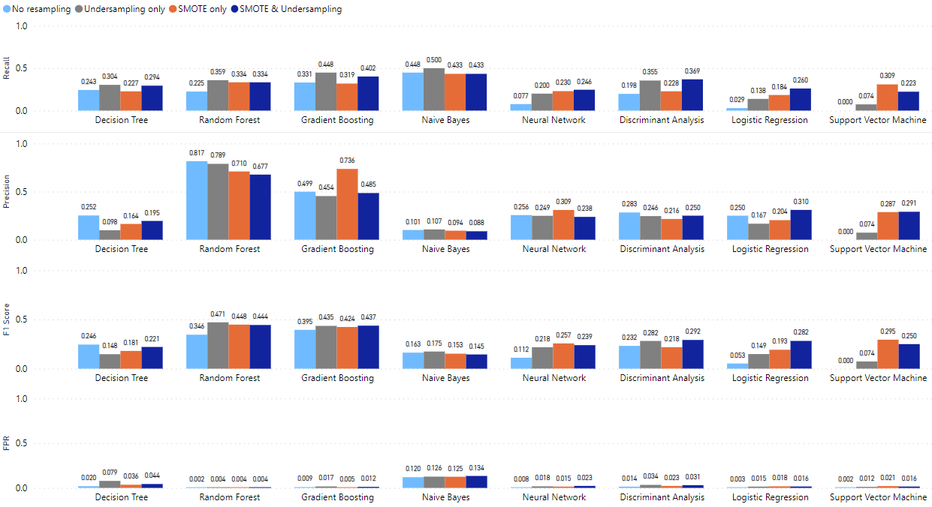

**Figure 20.** Performance comparison of models with and without resampling based on response time and summative statistics with a ratio of 10:1 between the non-cheater and cheater classes.